**16.Design TM using simulator to accept the input string anb2n.**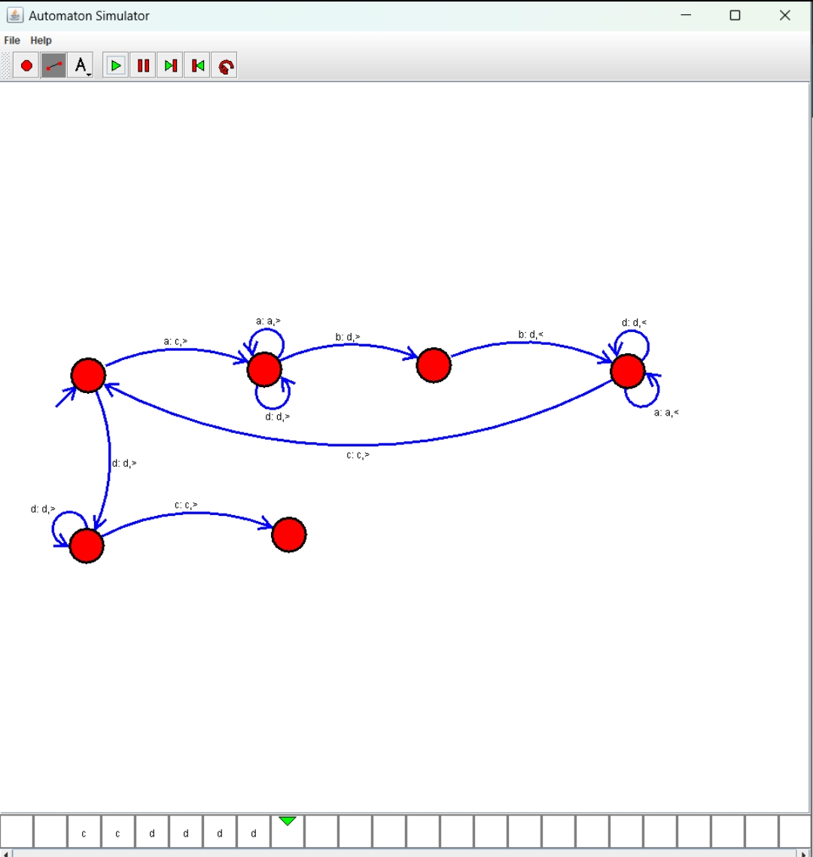

**Result: Hence, we Design TM using simulator to accept the input string anb2n**